REIMS
Crayere
Cave de Ruinart
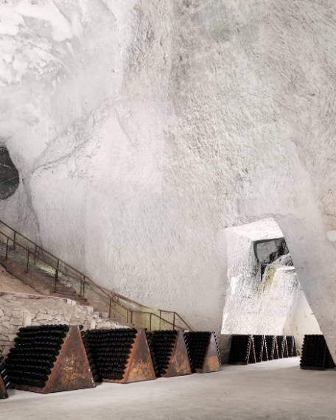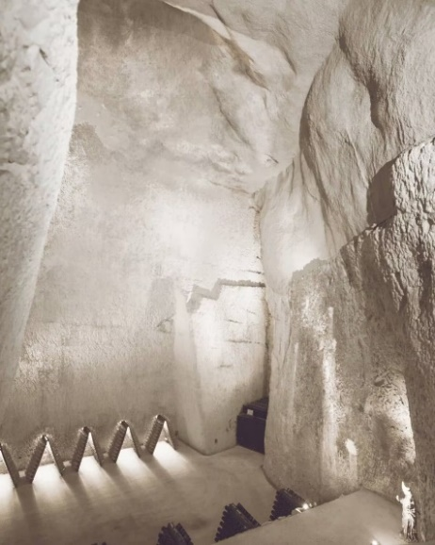

Between forest and vineyards, come and visit this typical village of the Montagne de Reims, considered to be the historic birthplace of Champagne wine. You can walk in the footsteps of the monk Dom Pérignon who, in the seventeenth century, in the Abbey of Hautvillers, laid the foundations for the elaboration of champagne. You can see the epitaph on his grave at the abbey church.
More than twenty Champagne winemakers, worthy heirs of Dom Pérignon, welcome you today to their cellars and farms to share with you their passion for the vineyard and wine, present their vintages and teach you how to sabre a champagne bottle.

Selestat
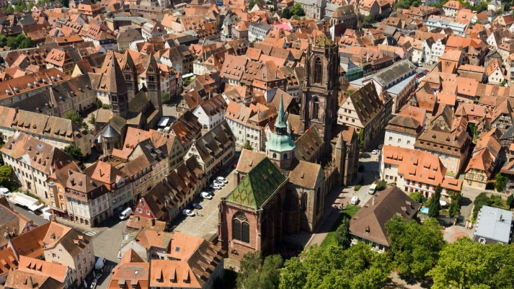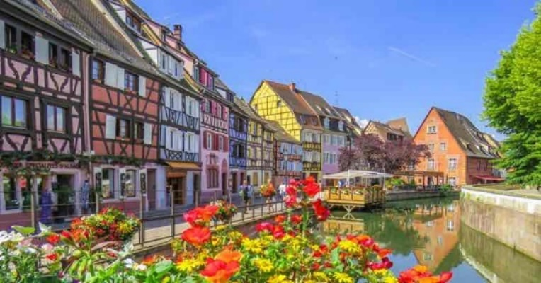
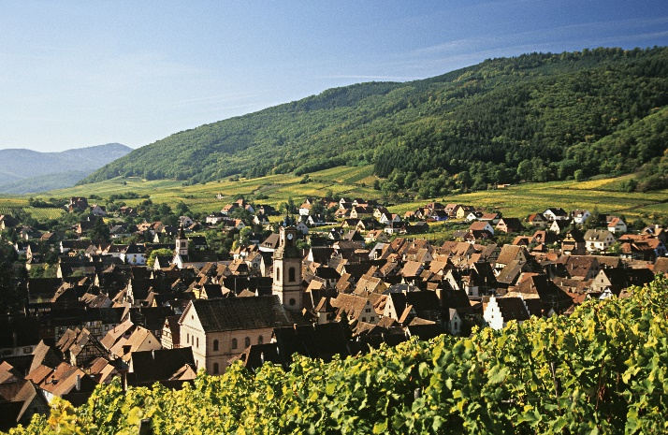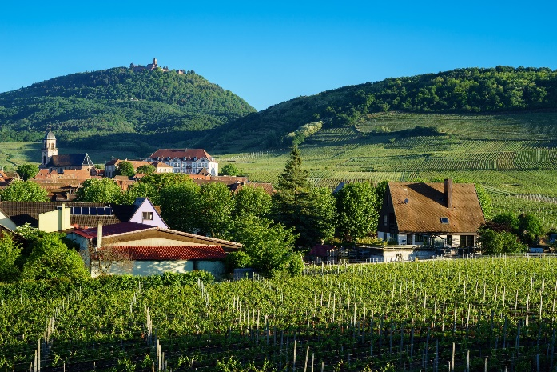
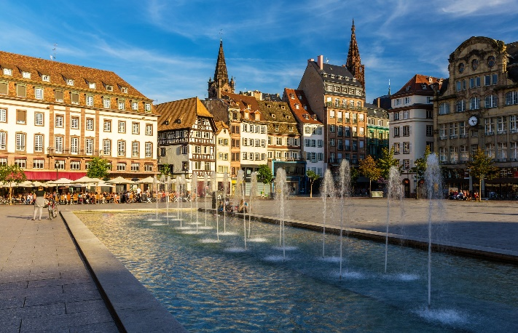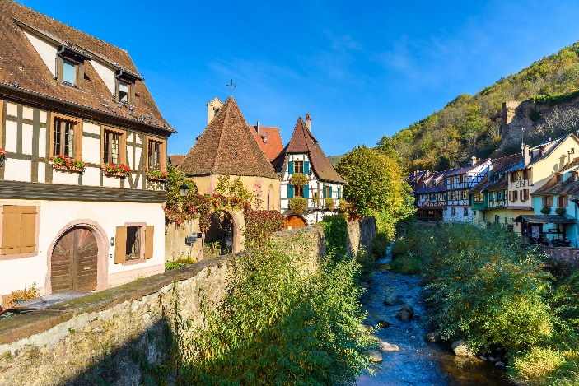
1521: THE ORIGINS OF THE FIR TREE
Sélestat has kept the oldest written mention of the Christmas tree, from December 21, 1521, when a payment of four schillings was made to the forest rangers to watch over the communal forest on St Thomas’s Day, the day on which fir trees were traditionally cut down. Many other references to the Christmas tree are archived in Sélestat.

Another long-standing story is the one that links Sélestat to the history of the Christmas tree, which is preserved in a register of the town's accounts. Dated 1521, this is the oldest known written reference to the Christmas tree in the world today.
Sélestat also has an important natural heritage with the Ill*Wald domain. A regional reserve where you can observe the largest population of wild deer in France, sail on the Ill in a kayak or walk along the paths.

Vendange d’Alsace from 29 august during 6 weeks
