IPC homework
Science
Name: ………………………………………………………… Class: ……………………………………
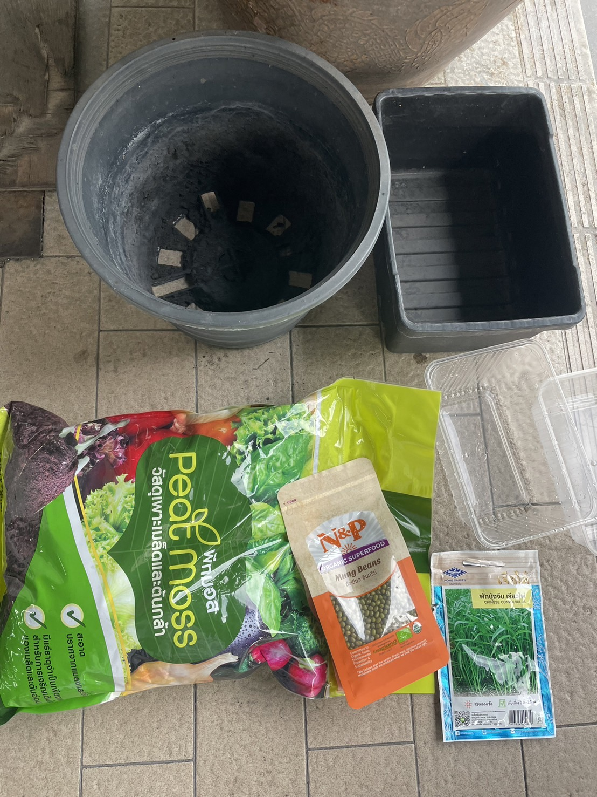
Material used:
1. ……………………………………………………..…….
2. ……………………………………………………..…….
3. ……………………………………………………..…….
4. ……………………………………………………..…….
5. ……………………………………………………..…….

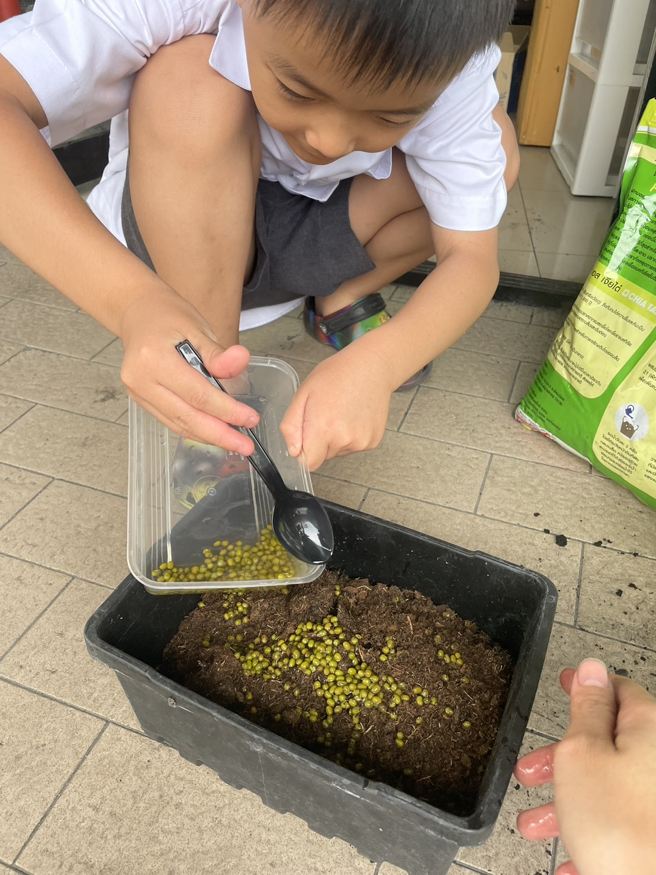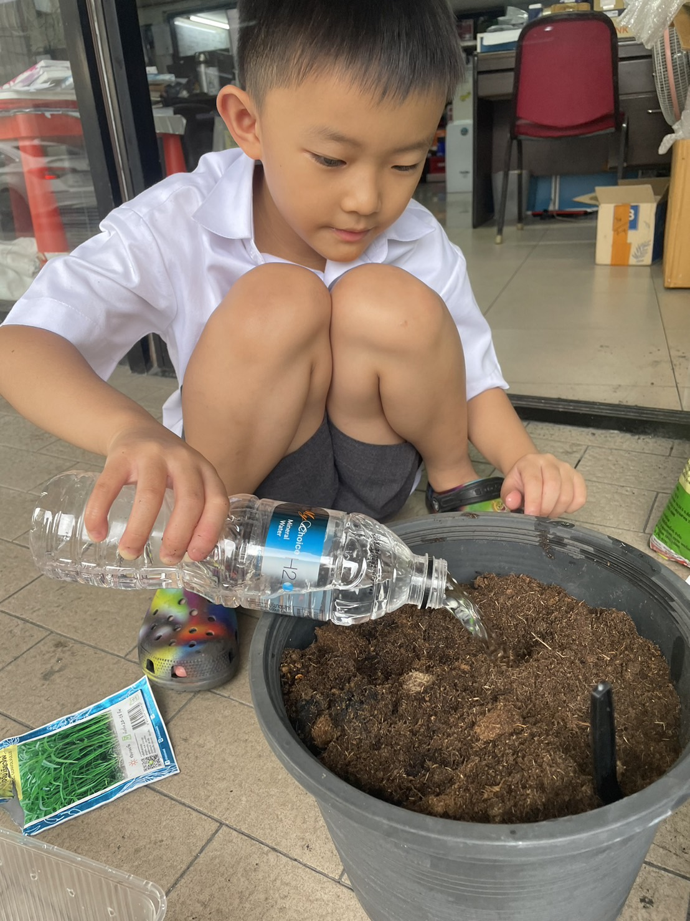
Explanation:
…………………………………………………………….…………
…………………………………………….…………………………
……………………………………………………………….………
.

Explanation:
……………………………………………………….………………
……………………………………………….………………………
………………………………………………….……………………
.

